The Real Santa Clause
Many centuries ago, Nick Cringle and his young son Chris had a very successful shop making wonderful carvings of animals, people and religious artefacts. They were taking their beautiful wood carvings to a village in Lapland in the north of Europe to sell at the local market. Suddenly Old Nick started to feel quite ill, so young Chris took his father to a nearby monastery so that he could get some help.
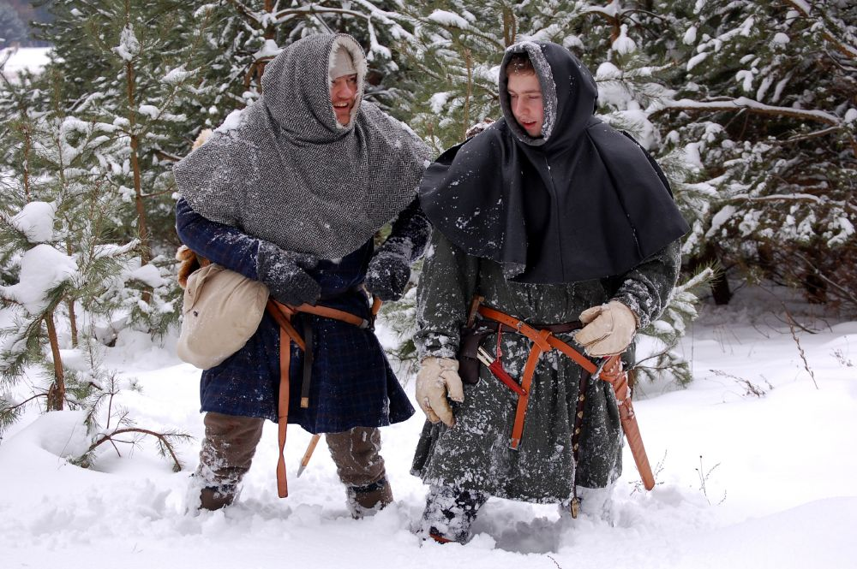
Old Nick became quite ill, so he asked to monks to look after young Chris and because he was very wealthy left money with the monks with instructions to house him and teach him and look after him. A few days later old Nick passed away leaving his six-year-old son Chris with the monks. The monks named him brother Nicholas (everyone in the monastery was called brother) and seeing the wonderful carvings that Chris had helped his father create, asked him to leave some carvings for their shop with the monastery especially the crosses of Christ, and wooden models of the virgin Mary and other religious artifacts for the monastery to sell in their gift shop.
Chris later moved from the shop to live in the monastery, Chris now known as (brother Nicholas), he learnt to read and write but his best skills were in his creative carvings. Although he enjoyed life at the monastery it became clear that he would not study for the order and by the time he was sixteen the monks suggested that he leave the monastery and try life outside, maybe setting up another shop. He still had access to the wealth from his father and he also got money from his religious carvings which were sold at the monastery.
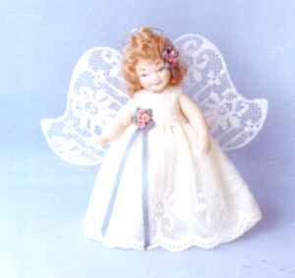
He asked to leave the majority of his wealth with the monks and use the funds as he needed them. But first he purchased a small shop just north of Norway and set up his wonderful carvings of gnomes, elves, animals and other small toys.
After a few years of success with the shop he only needed to return to the monastery when he wanted to sell them more crosses and statues, so he concentrated on expanding the toy carving business. The monks welcomed brother Nicholas because he brought them more carvings that were by far the best they had ever seen. Chris would carry the Christian carvings at the end of each year to the monastery.

One day in December when it was very cold and he was getting ready to take stuff to the monastery, he saw some young vagabonds staring into his shop looking at the brilliant toys and animals. He asked them to come into the shop and see if they would like to buy some toys. “We can't afford to buy anything” they said because we are so poor we just do not have the money.
Taken aback at this, brother Nicholas asked what they were getting for the festive season but all claimed nothing would be forthcoming. Because he had to pass through their village to get to the monastery, he suggested that they put a sock or stocking on their doorstep before Christmas eve, the night he would return from his journey.
How will you know where we live and how will you know that we have left our socks out? asked the young kids, well Nick put a candle in the window or if you have a tree in your garden then attach some ribbons or bright paper to the tree and I will know that is a house to visit. What if we do not have a tree nearby asked another girl, well there are lots of small pine trees around here, why not cut one down and put it in your window with baubles and bright ribbons, near a candle then I will see them as well.
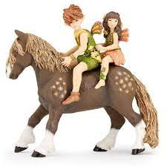
Brother Nicholas went back to the monastery and asked for some money in small denominations, and a bit extra to purchase some fruit. He collected some apples, nuts and some biscuits, and selected a small toy carving that he had made and carried these with him. After a while he noticed that he had quite a few items to distribute so he found a large sack and put all the items in the sack.
On the night before Christmas, he set off for the poor district with the sack over his shoulder, it was cold so he found a large cloak with fur cuffs, it was red but would do to keep him warm.
He set off walking till he saw the brightly decorated trees and he put a few coins, an apple and a toy into each sock that he found. He also added a few nuts so that was something nice for the kids to find on Christmas day.
Very tired and with an empty sack he walked back to his shop and had a drink of milk and went to bed in a great frame of mind.
During the next year he made extra toys to give out as gifts as he did previous year. The sack was quite full so it became heaver to carry but at least he had bought some strong black boots and long trousers which he added fur to the ankles they were also red to match his cloak.
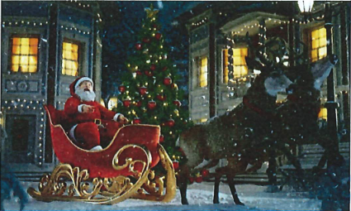
That year he found more socks and stockings on more trees but still managed to add some coins, gifts and food to each sock that he found. When he had visited the monastery, the monks asked why he was carrying suck a large sack and what he was doing with the small coins
from his funds that were held at the monastery, when he told them his story they were very happy that he had learnt some of his Christian ways from his days at the monastery.
Several years went by and he found he needed to make a lot more toys as the tradition of filling stockings became known throughout other villages, so he asked the small boys and girls from the poor area if they would like to help make the toys and animal carvings. Many agree to work with him and most were so skinny, so small he called them his little elves. He taught them how to make toys and create some carvings for the children.
By now he realized that walking with the heavy sack was becoming a problem I mean he was getting older, so he built a sleigh and painted it red, but to purchase a horse would be quite expensive, so what was he to do?
On his travels he passed through fields where Reindeer roamed so he started taking food and candy canes which they liked and soon they all became friendly. He found one particular reindeer that was quite responsive and friendly so he took the sleigh and tried to hitch the reindeer to the sleigh. After some time, the reindeer took to the sleight and Nicholas call the reindeer "Comet". They travelled around the field and the sleigh held the sack and Nick only fell over a few times so this seemed a great answer to Nick's problems.

That year using Comet and the sleigh Nick got around to many more houses and even went to other villages, where he found more trees with ribbons and so he started delivering goodies into the socks left outside the houses and those with bright trees in the window or garden or with candles lit to welcome him.
This continued for a few more years and as his reputation grew, he got more reindeer to help pull the sleigh, he named them Dasher, Dancer, Prancer, Vixen, Comet and Cupid. Which all now enjoyed pulling the sleigh and the special candy that he made for them, with Nicholas sitting in the now much larger sleigh. He had painted this one bright red again, and the sack was now getting to look just like his cloak as it absorbed some of the red paint.
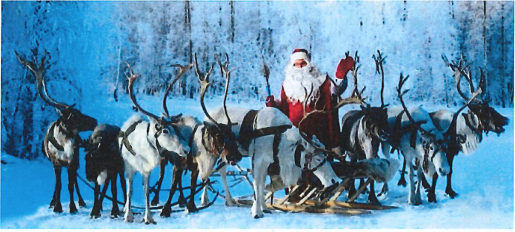

One problem he found was that because he was so far behind the reindeer he had difficulty seeing ahead, so he fitted a lamp to the front reindeer, and he found it better to put a single reindeer in front with the lamp, but to help not blind the reindeers he painted the back of the lamp, red, well he still had a lot of red paint left over. This reindeer he called Rudolph and all the other reindeer could see was the red from the back of the lamp reflected back onto Rudolf’s nose, so they knew which way to go and it was all working perfectly.
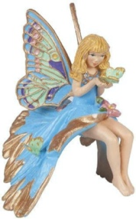
When brother Nick returned to the monastery for more funds the monks asked again what he was up to and after he told them that he had been looking after the poor children for many years, they agreed that he had done so much good for the community that they declared him a saint and from now on Chris Cringle, would be known as Saint Nicholas. In Lapland they say Saint as "Santa Nickolause"
When he told his helpers of his new title, they were still so small and young and most could not call this long name very well and being from the north, they knew that Saint became Santa and Nicholas they could not pronounce so they shortened it to become Clause, so they called him "Santa Clause".
His name then being easier to pronounce was spoken everywhere he visited as his tradition expanded across the world. Santa or Santa Clause became the name all the boys and girls looked forward to hearing each year, as long as they were good they might get a gift. Each year he took presents out on Christmas Eve and he looked after all those that had left a brightly decorated tree either outside or inside the window, and he found people started to add more decorations including some of his carvings of people, houses and in particular a star or a fairy, and if you look carefully at Christmas trees today you may see some small items just like those that Santa made, they also started to decorate the house with candles in bottles or lights so that he could tell where the children had left their socks and some even left him a drink and a snack because he was working so hard and some put their socks over the fireplace because they knew he would be cold so he could warm himself whilst filling the Christmas stockings.
Eventually he added two more reindeer "Dunder" and "Blixem" (come from the German phrase for thunder and lightning) and continued to venture out each Christmas to give out gifts so the world got to know the name Santa Clause and a tradition began, so the boy we knew as Chris Cringle, "young Nick", then brother Nick and eventually Sainta Nichoclause, became one of the most famous names in the world and even today we know the kids, and in fact every one looks forward to seeing Santa Clause on Christmas eve.
His tradition continues to this day so thank you Saint Nicholas and to the young elves helping in the shop and to the reindeers Dasher, Dancer, Prancer, Vixen, Comet, Cupid, Donner, Blitzen and Rudolph.
They really did exist and if you look careful you might see them crossing the sky and if you are good you might find your sock full of nice gifts.
Written by Peter Faulks
Images
https://a-z-animals.com/bloQ/christmas-reindeer-whats-the-storv-behind-santa-and-reindeer/

